**Name of the Event: Collaborating to Amplify Development Impact in Kolhan Region**

**Date: 22nd Sep, 2022**

**Venue: Jamshedpur**

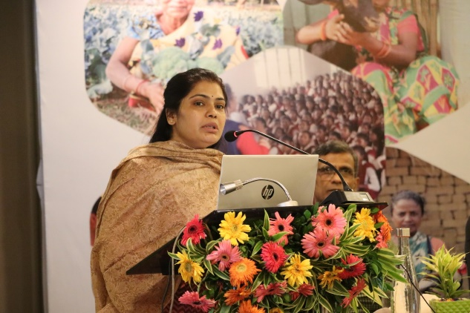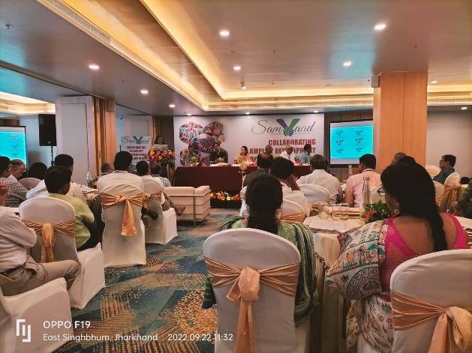A one-day program was organized under the joint aegis of Civil Society Organization (CSO), Corporate Social Responsibility (CSR) and district administration to increase the development activity in Kolhan division. The program started by welcoming the participants and guests by R Santoshi ji of JAMIPOL. After that, by Sarbani Bose, the theme of the program and its objectives were widely shared among the people through presentation. The participants were divided into three different groups for discussion in the middle of the program. These three groups were education, health and nutrition and livelihood. All these groups discussed and consolidated things.

**Ms. Vijaya Jadhav, Deputy Commissioner East Singhbhum** said that it is a very golden opportunity when the Government, Civil Society Organization and Corporate Social Responsibility (CSR) have made joint efforts for development works, which is a commendable step. He said that SDG Inspired people to work in it by dividing it into three main sections social, economic, and environmental.

**The chief guest of the program, Abu Bakr Siddiqui, Secretary to the Government**, Department of Agriculture, Animal Husbandry and Co-Operation-Mining, joined through online medium. He said that with the help of such participation, Jharkhand SDG would be able to achieve this goal. can achieve its goals. Livelihood models developed by various institutions such as Integrated Agricultural Promotion, Natural Organic Farming and other models can be developed on a large scale. There is a need to strengthen this type of dialogue program, in which the role of civil society organization and Corporate Social Responsibility (CSR) also needs to be ensured along with the role of the government.

**Mr. Saurav Roy, Chief CSR Officer, Tata Steel** said that to strengthen the activities of the community, there is a need to understand the environment of the community and at the same time there is a need to develop skills and capacity of the people in the area of ​​community development.

**XLRI Director Father SJ George** said that a change in mindset and strong self-confidence is needed for big change, only then change is possible in a state like Jharkhand.

The program was concluded by Pradan Ke Manas Satpathy, in which he talked about implementing the combined strategy that emerged through the workshop in all areas.